8-4 Journal: Portfolio Submission

Lynn McCargar

CS-330-T2653 Comp Graphic and Visualization 21EW2

Prof. Brian Holbert, Ph.D.

Southern New Hampshire University

My initial thought for my design was to use complex shapes, because I like to be challenged with technology. But this would not be possible with this course due to the inconsistent configuration instructions, use of non-industry hardcoding environmental paths, and the use of deprecated libraries. So instead I went for a less complicated scene a desk top with a paper weight, a keyboard, and a desk lamp.  
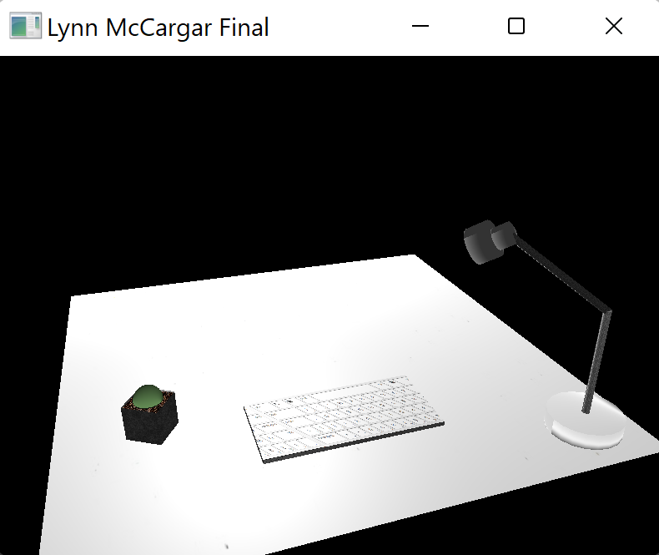

The lamp was the most complicated with five bindings to draw the lamp. This was the most difficult part of the project.

One of my first succusses in this course was mapping the GLFW keys to WASD plus QEP. The WASD GLFW key were examples of what I thought would be a simple ‘if’ conditions for the other keys, that was not the case. The QE keys were not set in the ‘ProcessKeyboard’ so I could not simple give the ‘if’ condition the ‘UP’ or ‘DOWN’ value. I believe this was a very clever way to introduce the camera header file ‘camera.h’ where much of the scene is controlled. The ‘P’ mapping is the ortho view.   
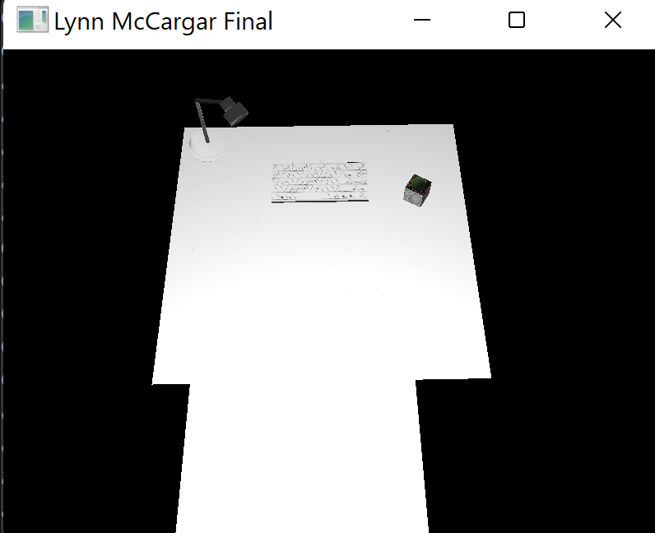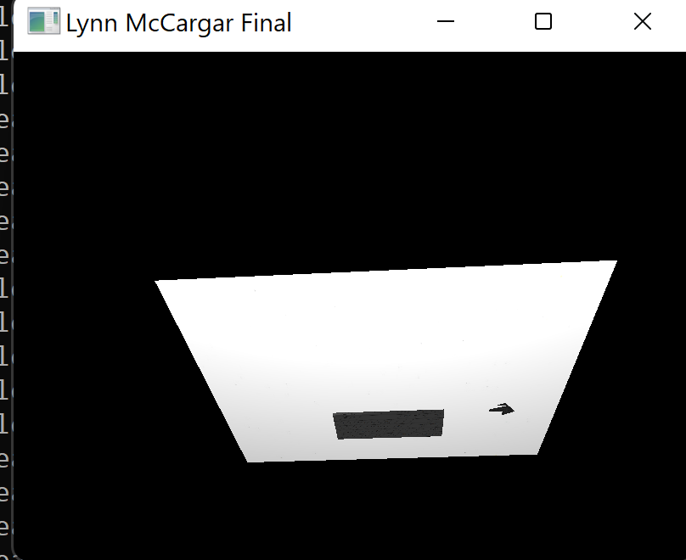  
I do look forward in possibly doing some real world work in 3d graphics, but will mostly using newer libraries such as Vulkan which a replacement for OpenGL, albeit there are some industries still using OpenGL, where less control over 3d objects are needed. Going forward I will be learning Vulkan and possibly get more involved with 3d graphics.